To make contact groups in Gmail:
Note: This is useful if you want to organize the group by parents , teachers or even class periods for easy grading.
1) Log into your Google Account and select "Contacts" from the top menu bar.
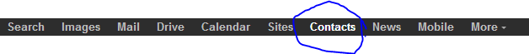
2) Select "New Group" from the menu bar on the left.
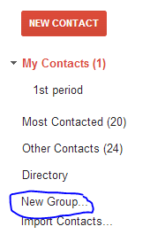
3) Type in the name of the group and click "ok"
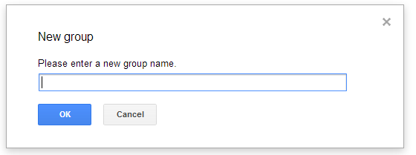
4) For example reasons, I named the group "1st period". You could name them "Parents 13/14", staff 13/14, or anything else that fits the organization.

