To add contacts to a previously created contact group in Gmail:
1) Log into your Google Account
2) Select "Mail" from the top menu bar
3) Click "Contact info"
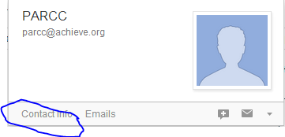
4) If needed, add the name of the contact. (Note: Most emails come with that already entered)
5) Click "Groups"
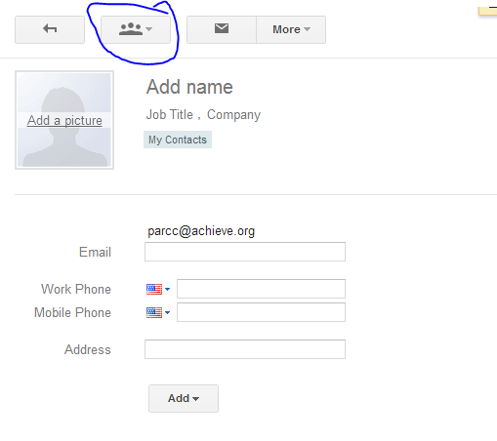
6) Select the group that you wish the contact to be a part of. (For my example, I used "1st period")
Click to check it and select "apply"
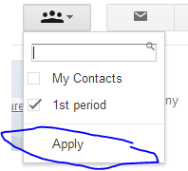
7) Repeat these steps until your group has all of the members that you wish to be added.

