Logging Into Gmail (Quick Guide)

1) Go to http://google.com

2) Type in your email address like you did for our old email system

Ex: sean.whelan@westg.org

3) Use the default password that I mentioned on convocation day.

4) A screen will pop up asking you to accept the “terms of service agreement”. You want to accept this.

5) Click on the word mail at the top menu bar

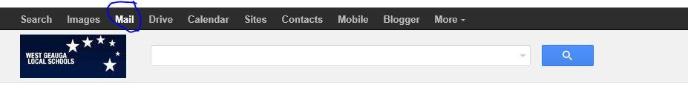
6) You should now be in your email account.

Change Your Password

1) Click on the icon to the right of the screen that looks like a gear.

2) Click on the word “settings”

3) Next, choose “accounts”

4) Then, “google account settings”

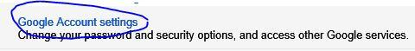
5) Choose “manage security” on the right side of the screen

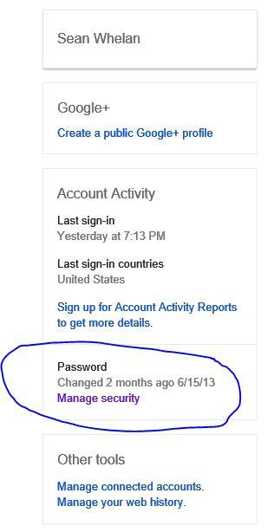
6) “change password” will be next

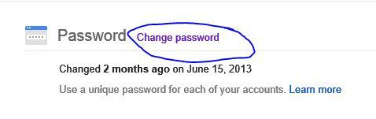
7) Choose your new password and click “change password” and you are done!
