Weighted Averages Final Step
1) If you selected the weighted averages option, you have one final step for it to give a weighted average.
2) When you have entered grades, click on the grade book. EX: "English"
3) Once in that grade book, you need to click "calculate averages" for it to reflect the weights that you set up for those assignments.
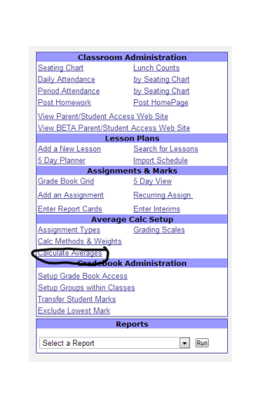
4) After you have done this, when you select "grid" and look at the overall total, it will reflect the assignment weights that you set. You can do this when you enter the assignments but definitely make sure to do this before posting to report cards so that the average is correct.
5) Please contact me if I can help further. This step wasn't in the original directions that we were given.

