Printing Report Cards / Generate Report Cards
You can generate elementary standards-based report cards for all the students in an entire school building at once by grade level, by homeroom, or for an individual student.
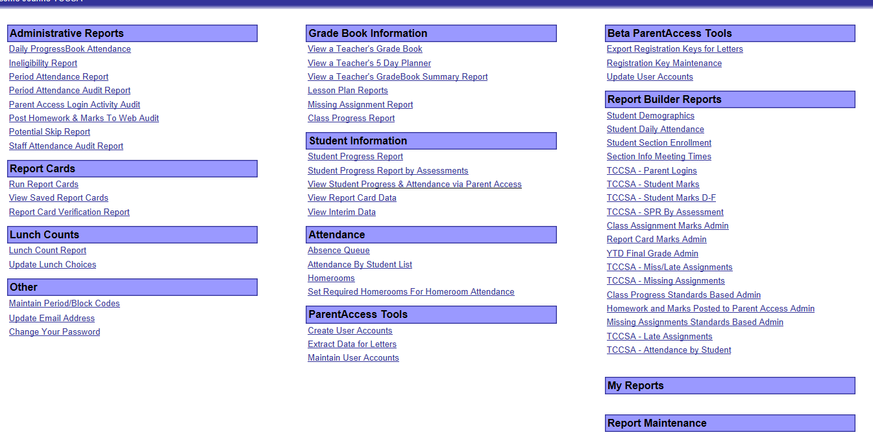
- On the Administrator Home Page, select Report Cards in the Run a Report list, and then click Run .

- On the Generate Report Cards screen, select the appropriate report card in the list.
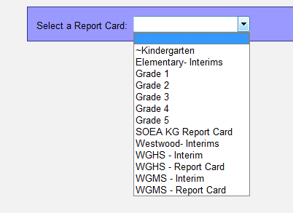

- Select the appropriate school in the list.
- Select any of the following optional criteria, as desired.
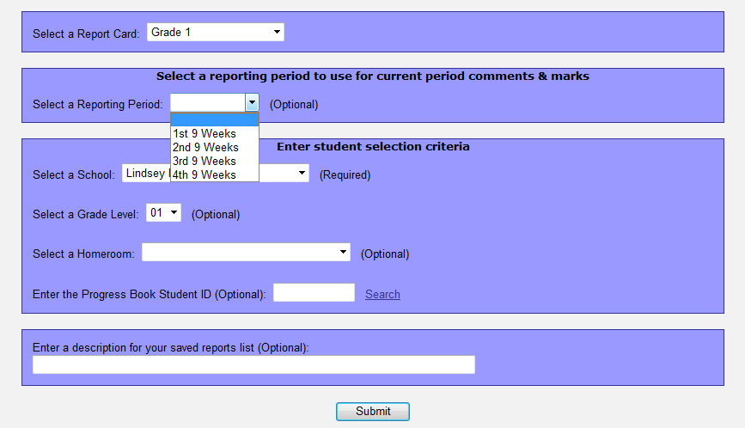

Reporting Period (Although it is marked optional. Select a grading period.)
Select a School
Grade Level – generates report cards for a specific grade.
Homeroom (optional)
ProgressBook Student ID number (If you are running only 1 student’s report card.)

To name the report card so that it is easy to find in the list of saved report cards, enter a description for the saved reports list.
- Click Submit.
If the report cards generated successfully, the following message displays under the Submit button, "Completed Successfully."
- Click the View Saved Report Cards link under the Submit button to view the report cards.
